How to download R and RStudio

# Downloading R

1. Go to <https://www.r-project.org/>
2. Click Download R

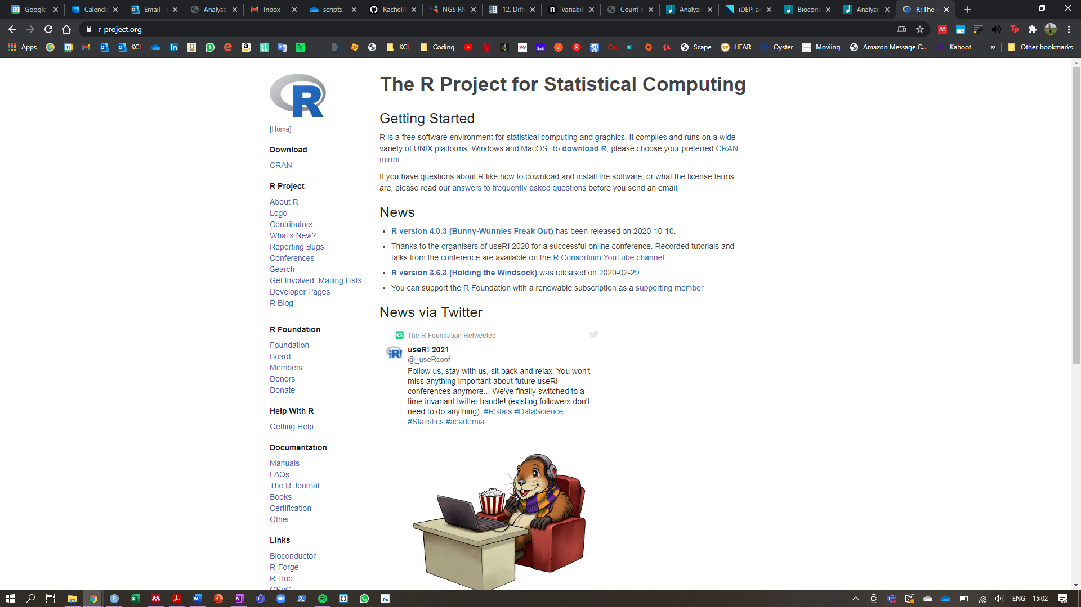

1. 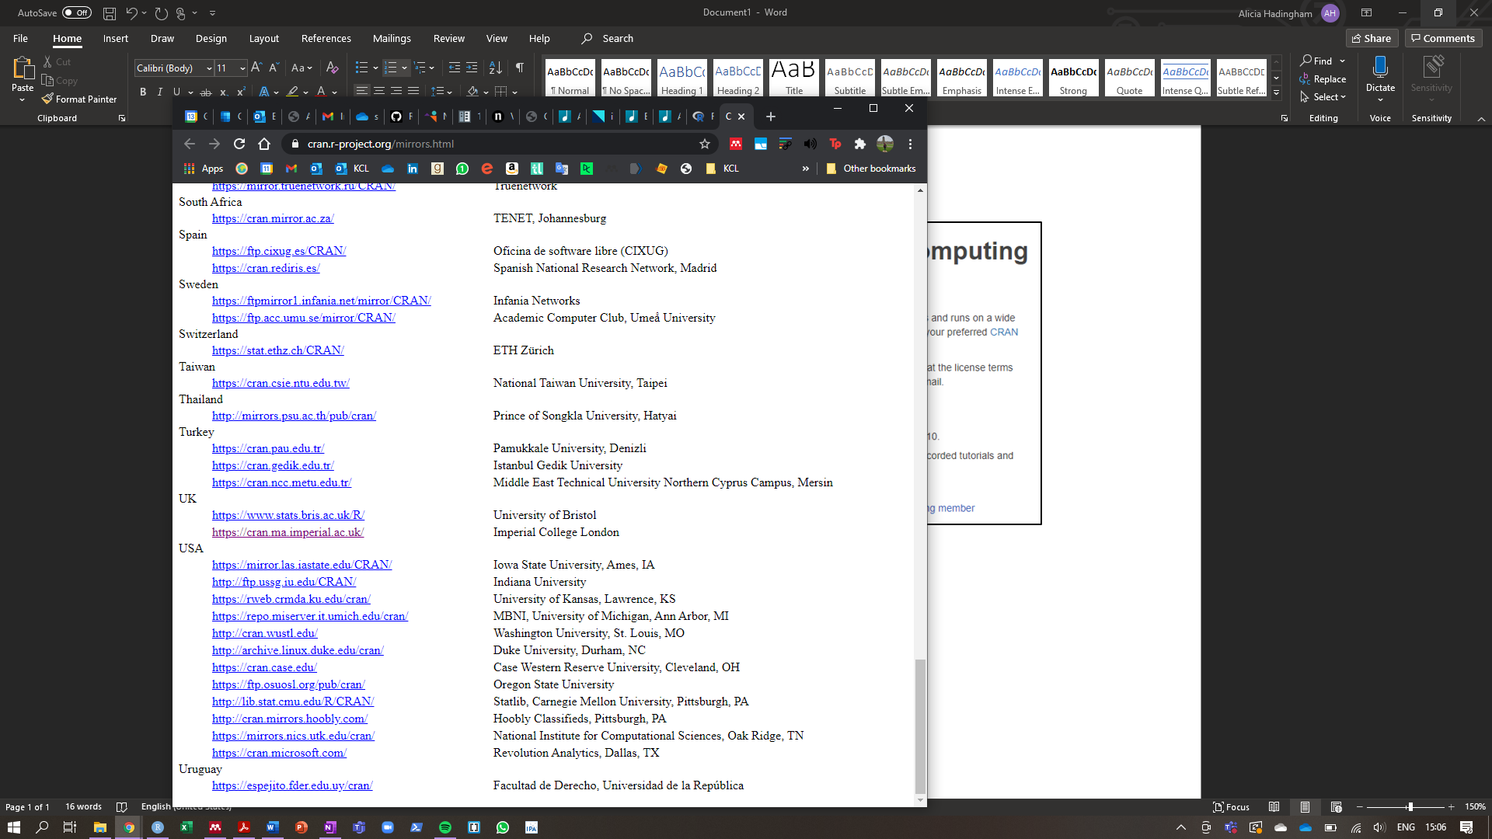Scroll down and click on one of the UK options
2. 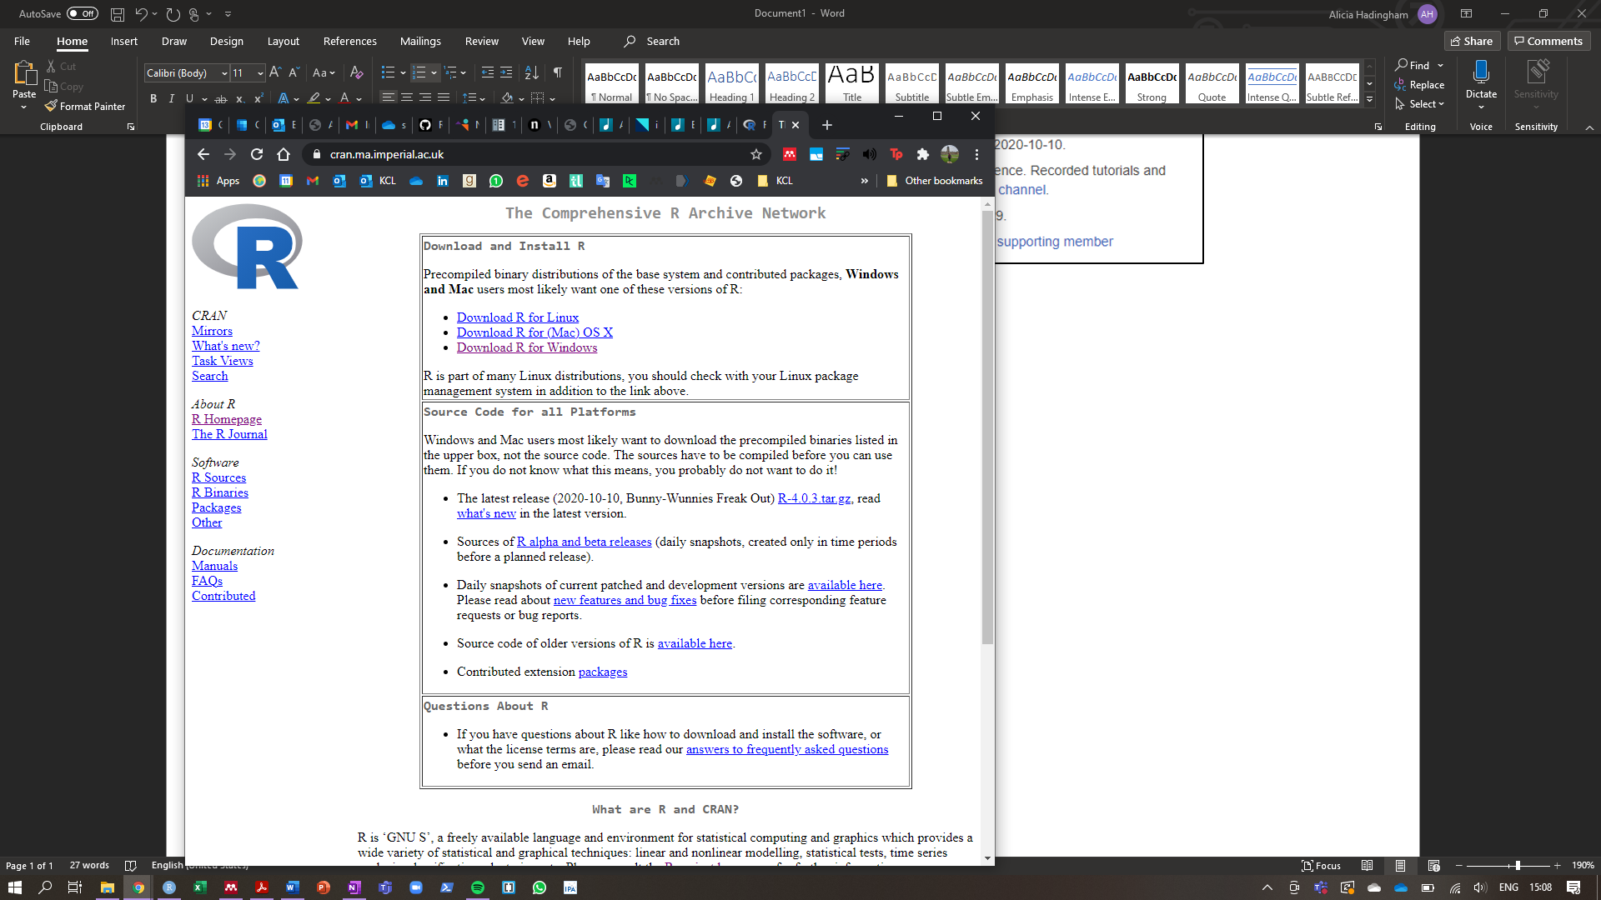Click on the download link for either Windows/PC, Mac/Apple or Linux depending on what computer you will be using.
3. Click base

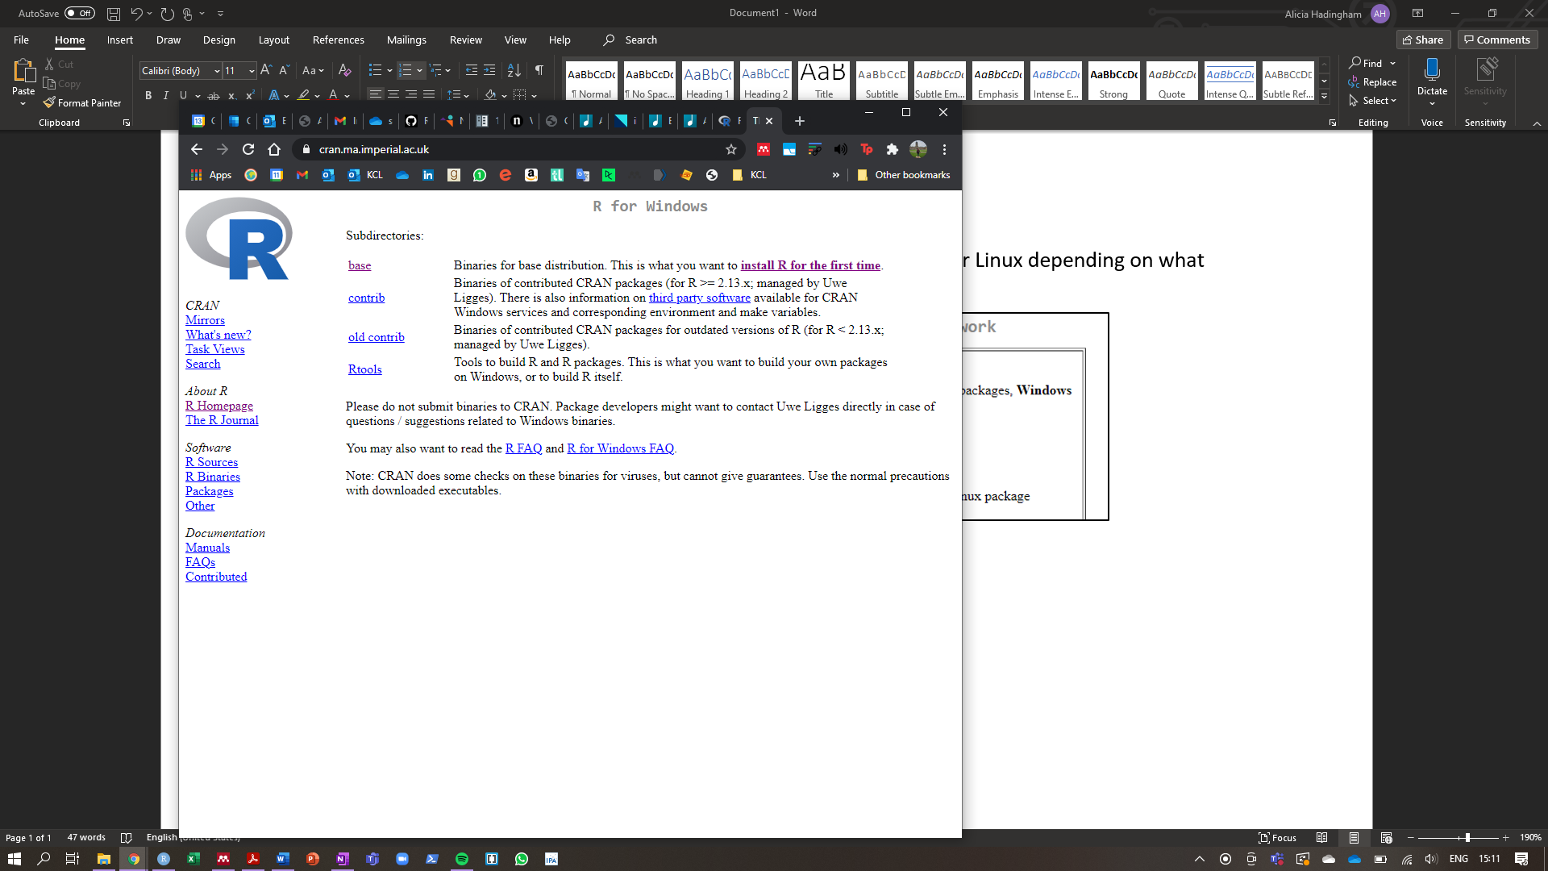

1. Click Download R

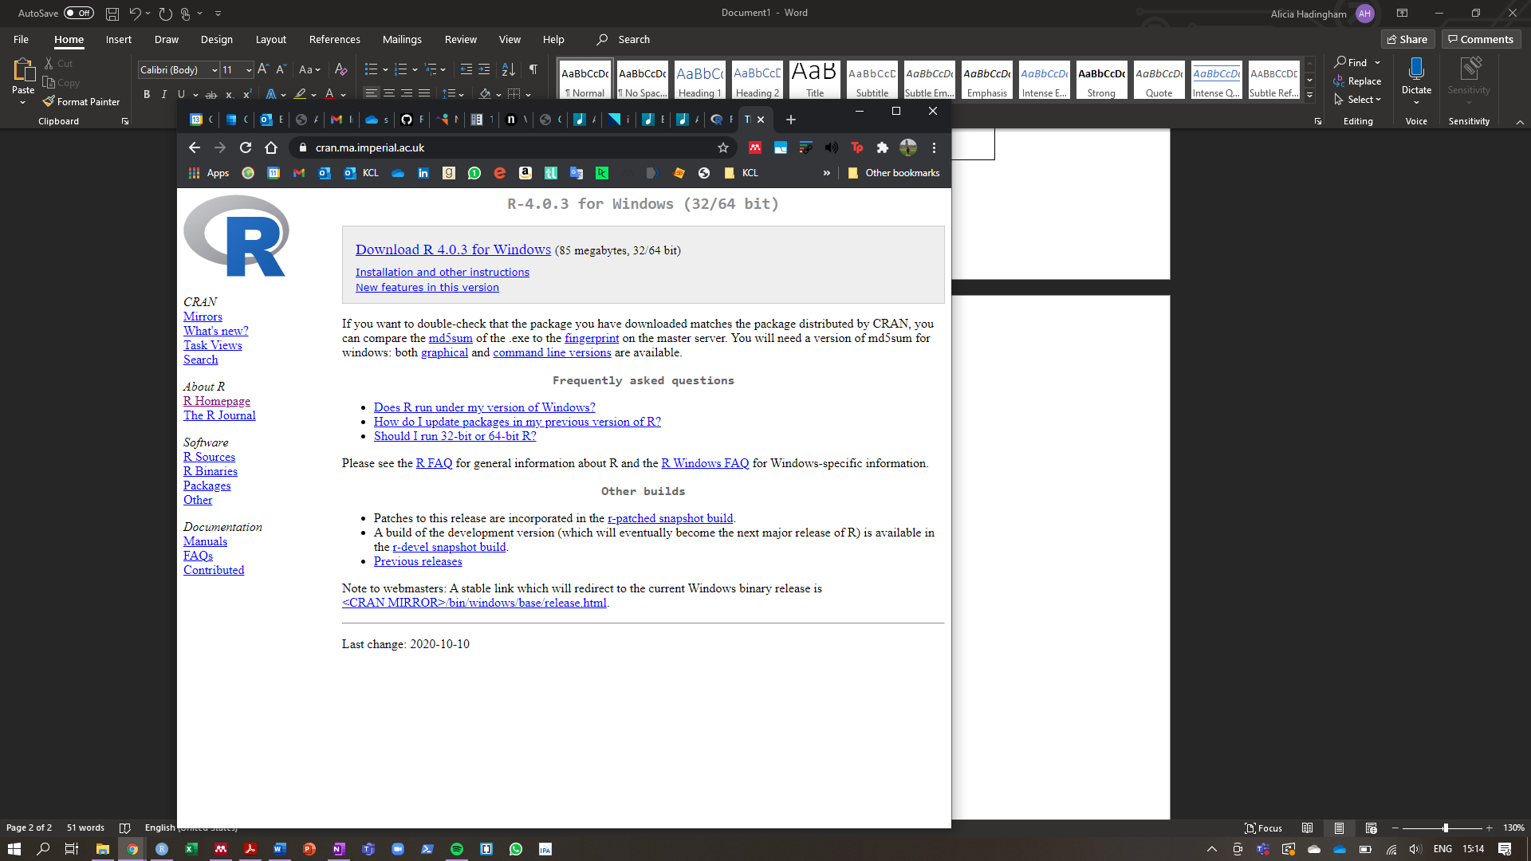

1. 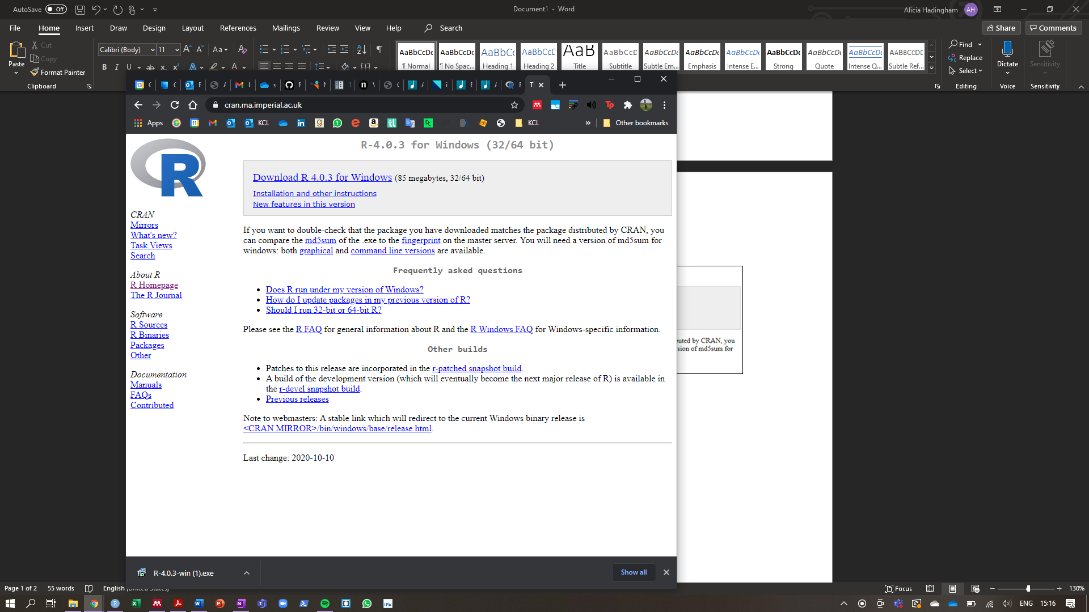Click to open the downloaded file
2. Click ‘Yes’ when the pop up says ‘Do you want to allow this app to make changes to your device’
3. Click ‘OK’ for the installation language to be English

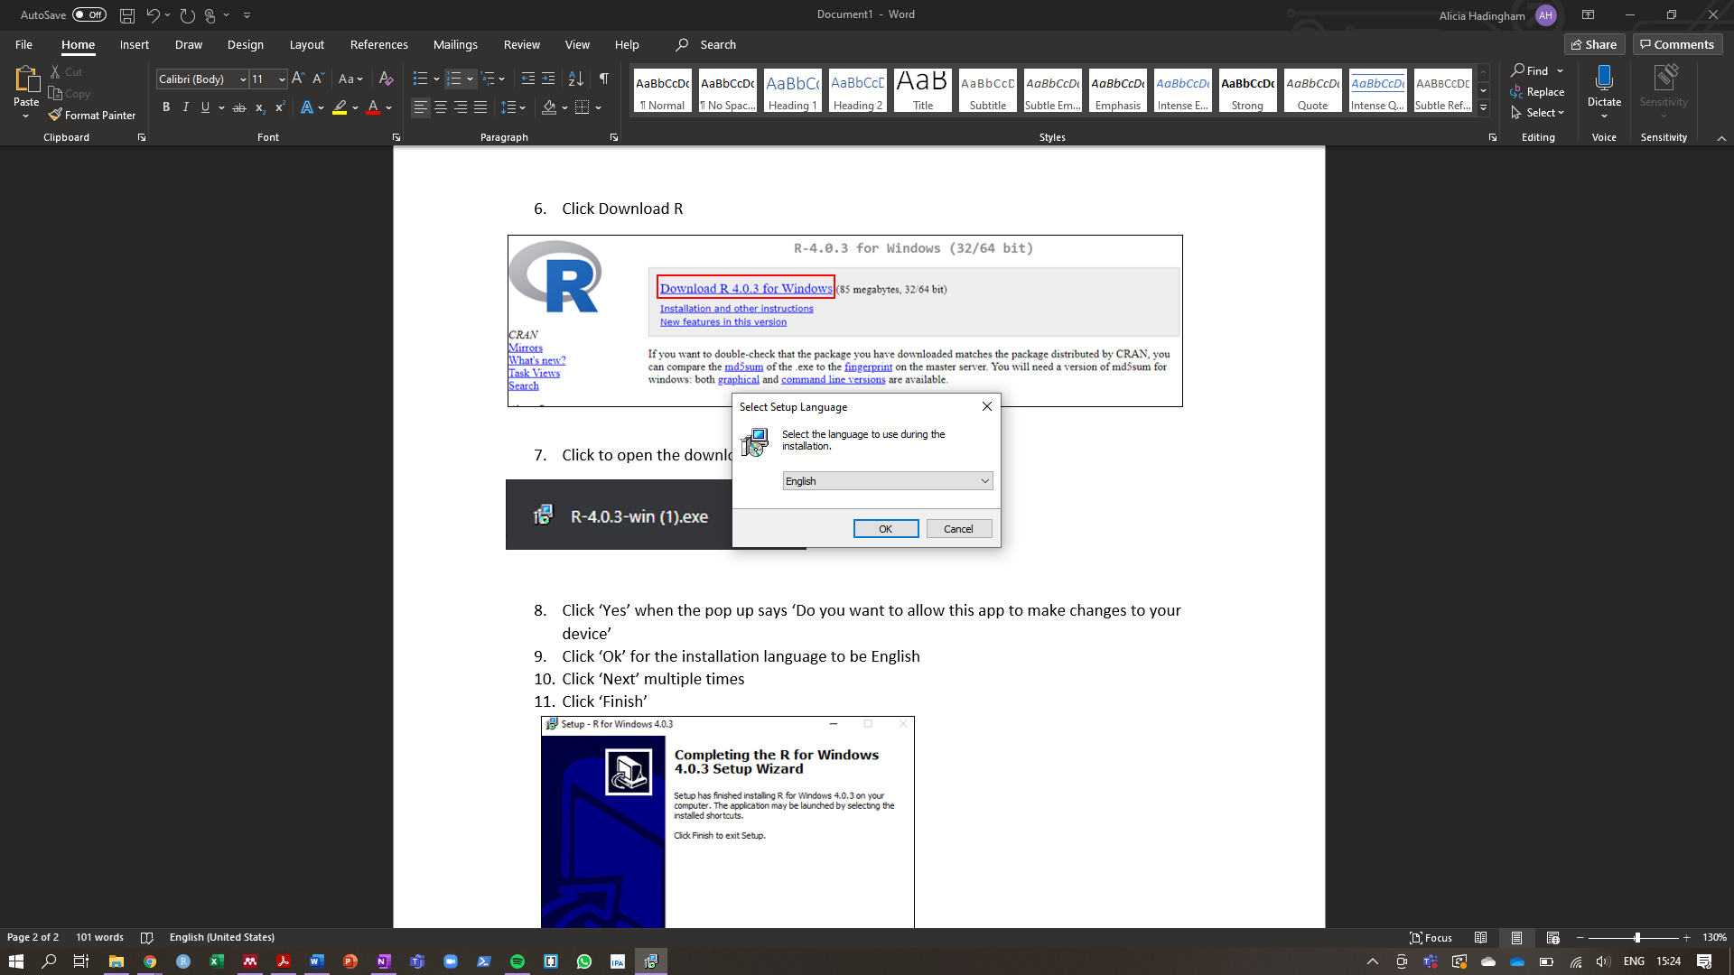

1. Click ‘Next’ multiple times

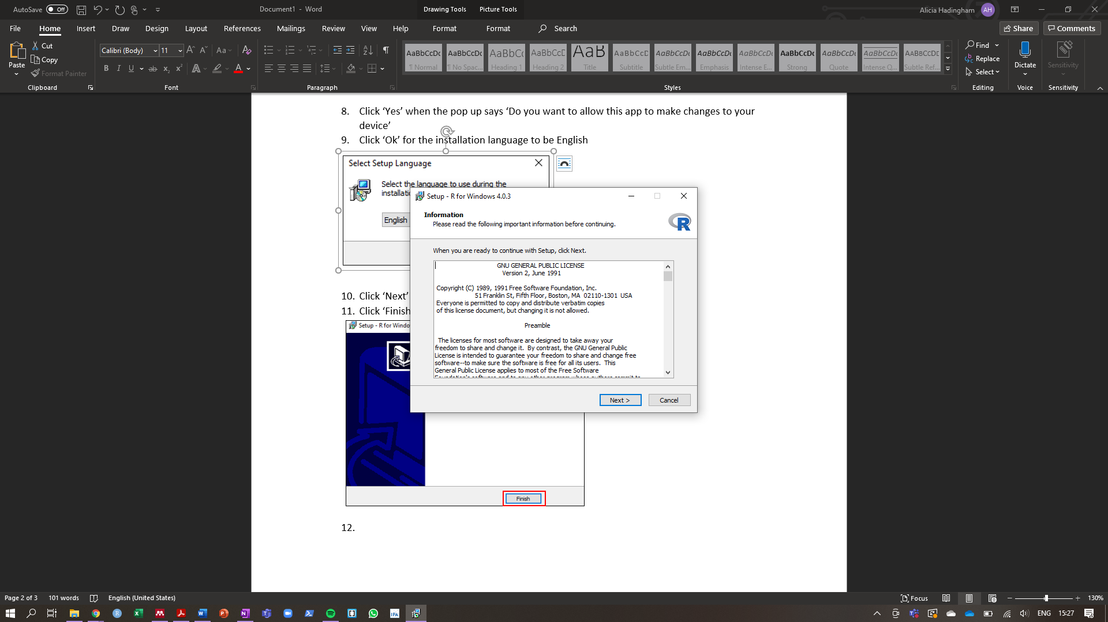

1. Click ‘Finish’

# Downloading RStudio

1. Go to <https://rstudio.com/products/rstudio/download/#download>
2. Click ‘Download RStudio’

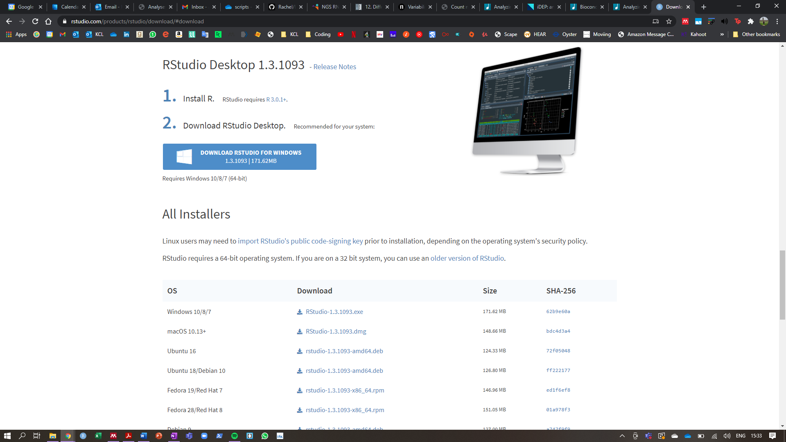

1. 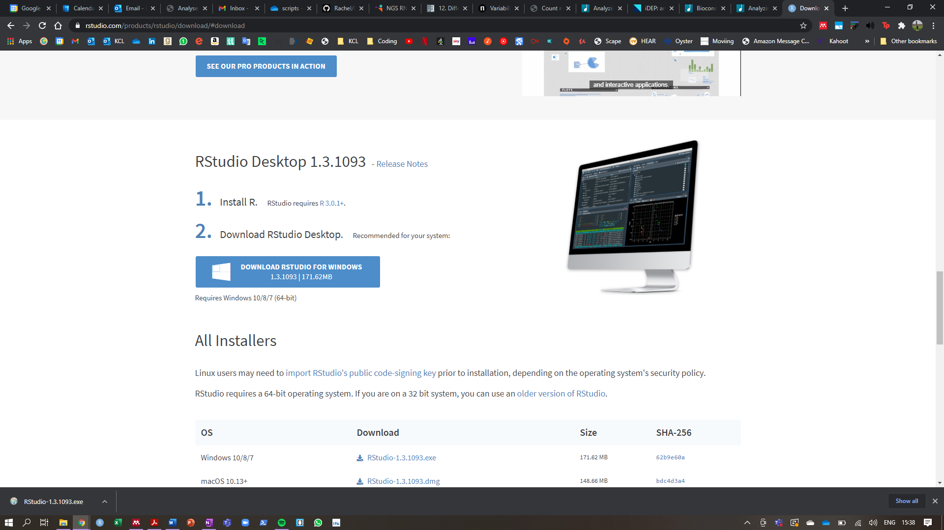Click to open the downloaded file
2. Click ‘Yes’ when the pop up says ‘Do you want to allow this app to make changes to your device’
3. Click ‘Next’ multiple times

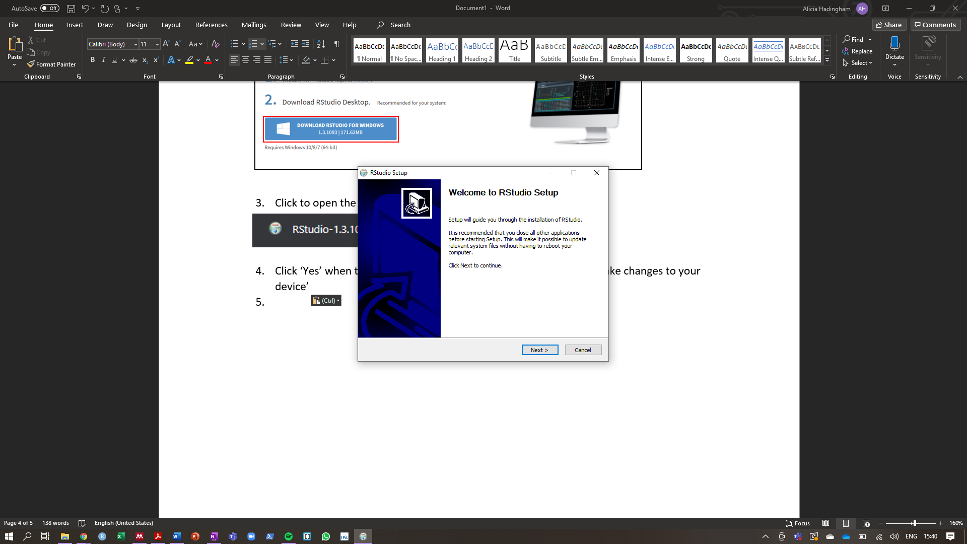

1. Click ‘Finish’